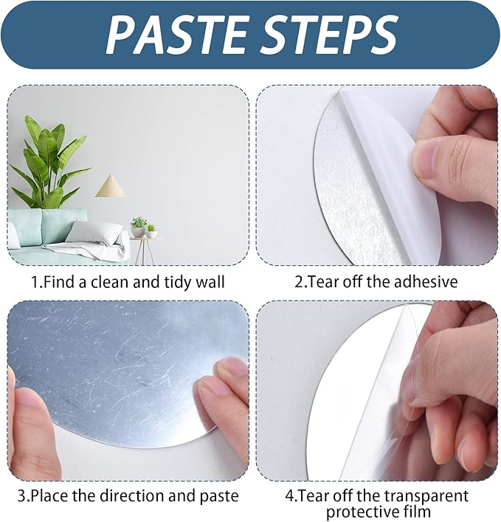

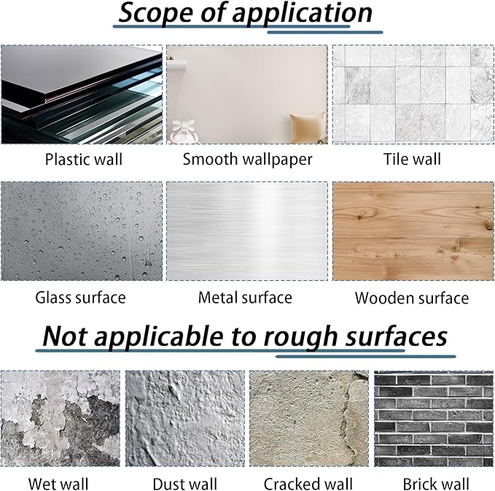

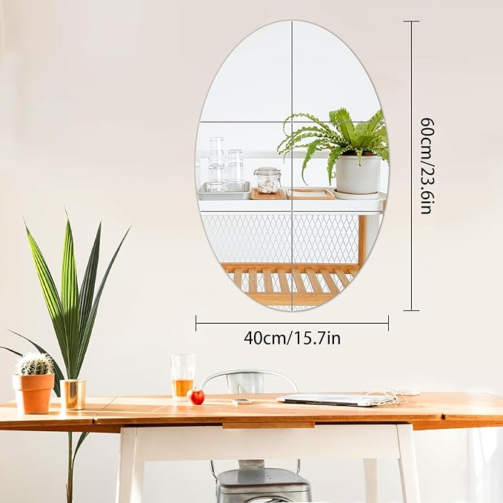

CEYAZYE Wall Mirror Tiles, 6 Pcs Oval Mirrors for Wall, Self Adhesive Wall Mirror Stickers, Acrylic Mirror Cute Room Wall Decor Y2k Aesthetic Living Room Bedroom Décor

**PRODUCT DESCRIPTION:**

|  |  |
| --- | --- |
| **Brand** | CEYAZYE |
| **Room Type** | Dressing Room, Bedroom, Living Room, Dining Room |
| **Shape** | Oval |
| **Product Dimensions** | 1"L x 1"W |
| **Frame Material** | Acrylic |

**About this item**

* 【Package Includes】You will receive a set of 6 Oval mirrors for wall, you can buy multiple sets of mirror tiles to DIY any shape you want. It's cool stuff for your room.
* 【Highly Reflective】Our acrylic mirrors are mainly used for room decorations. The reflection of the wall mirrors can make an otherwise small space look bigger and brighter. The mirrors are integrated with the wall, do not take up space and have an aesthetic design.
* 【Easy Installation】Peel off the protective film on the surface of the acrylic mirror to get mirror wall stickers. Self-adhesive backing design makes the bedroom mirror easy to stick on walls, doors, closets and any smooth surfaces without drilling holes and won't damage the wall.
* 【Unbreakable】Compared with ordinary glass mirrors, our room mirrors are made of acrylic material, the biggest advantage of this material is that it is not easy to break, safer and more environmentally friendly, sturdy and durable, can be used for a long time.
* 【Multiple Uses】Our mirror sticker can be used in rooms, living rooms, bathrooms, dormitories, corridors, stores, flower rooms, locker rooms, gyms, offices and various other places, making the room look bigger and brighter with more design, making your home more cozy and beautiful.